A free AWS course presendted by Yes-M Systems LLC

Prepared and presented by MS Viswanath

Lab manual – EC2 Instance

1. Select the AMI image

Options 🡪 AMI, Custom AMI, AWS Marketplace, Community AMI

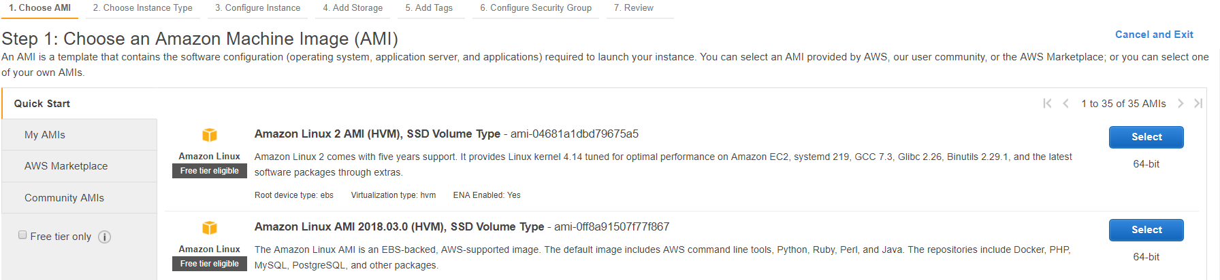

1. Select “instance Type”

Options 🡪 CPU, RAM, Instance storage, Network performace.

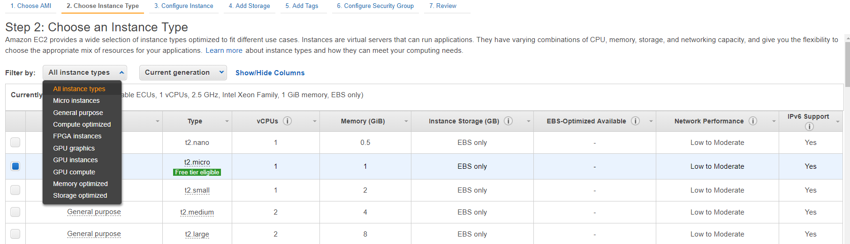

Type 🡪 t2, t3, m2, c3, c4 …………………

1. Instance Configuration

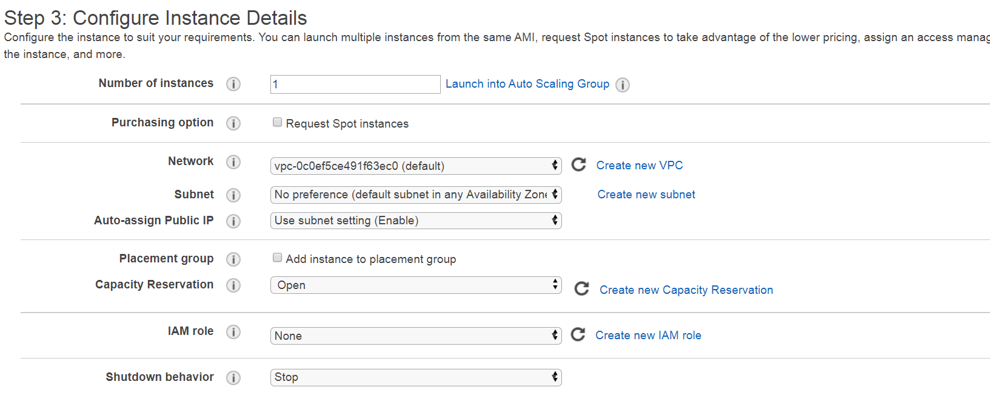

1. Add Storage

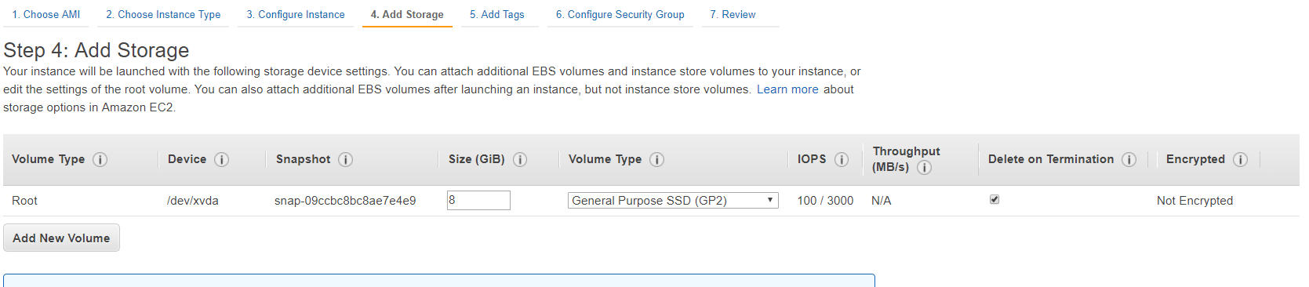

Option 🡪

Volume Size 🡪 For root volume we can go upto 2TB, and for additional data volume upto 16TB

Volume Type 🡪

General Purpose SSD 🡪 AWS provides, 3 IOPS for every 1 GB, MAX IOPS -- 10000

Provisioned SSD 🡪 50 IOPS are provided for every 1GB. Max IOPS – 32000

1. Add Tags

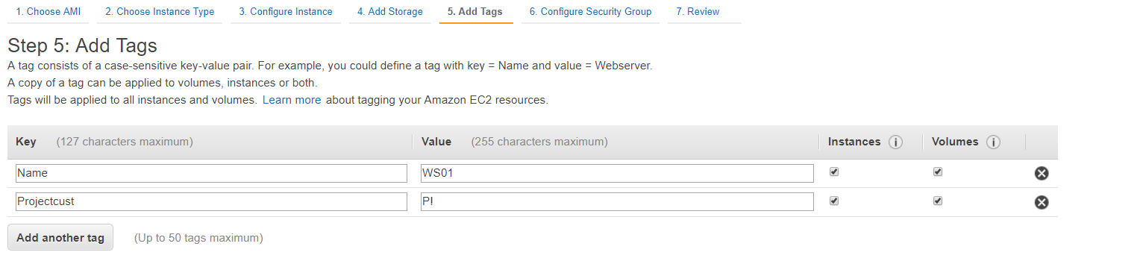

Provide an proper TAGS , that would be very useful on a long run.

Think we are managing 1000 VM’s and you have to manage it.

1. Add Security

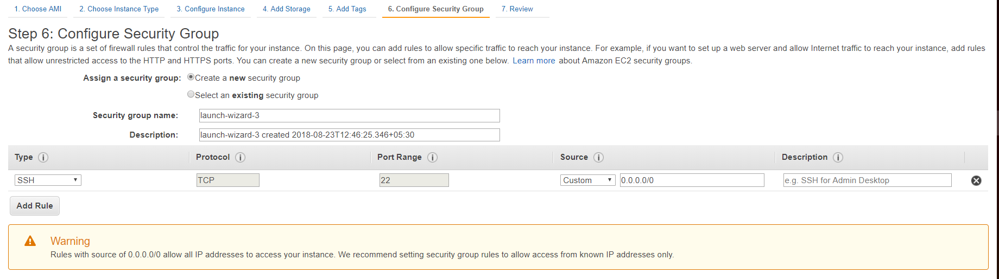

The above is the inbound traffic that is listed for this instance. ( SSH is allowed for Linux OS, to be access from outside), we would talk about this more in the “AWS SECURITY” session.

By Default ALL TRAFFIC is ALLOWED for outbound traffic.

1. Review

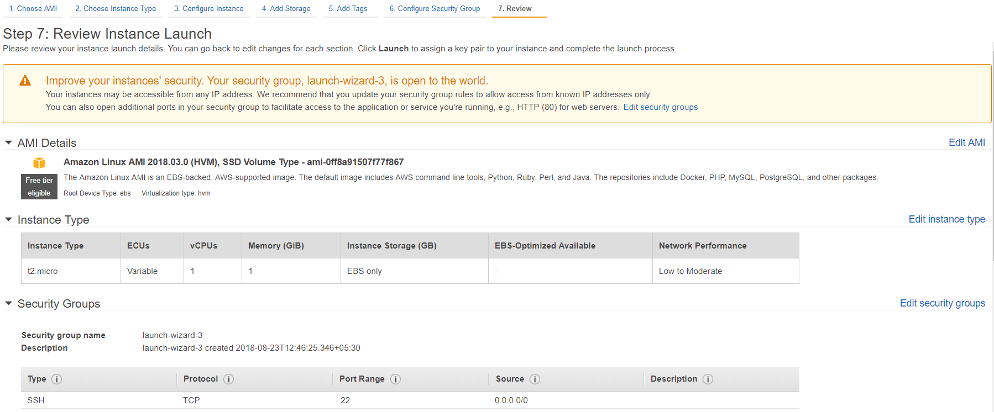

1. Key Selection

For EC2 Instance we would need to assign an “KEY” to access it. This would be the password.

There is an DEFAULT “Username” for every IMAGE that we select in the beginning.

The key has 2 parts, Public and Private.

The private key is downloadable only ONCE and AWS DOES NOT STORAGE it.

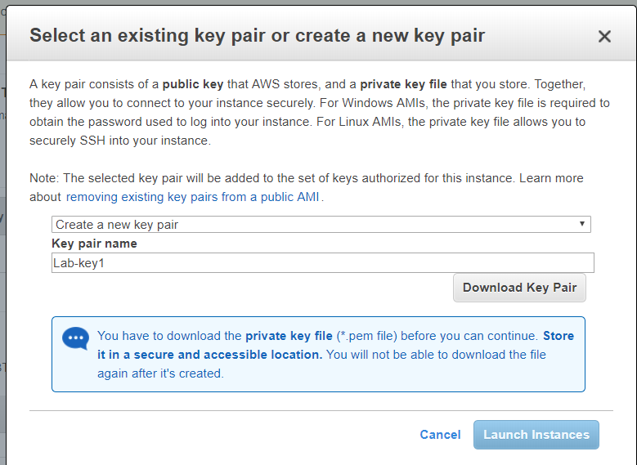

Until we download the key pair for the first time, “Launch Instance” button does not get activated.

After the download of the key, Click on “Launch”.

**Output 🡪**

